Stepstone Integration Setup and Vacancy Publishing

visit www.dynamics-hr-management.com

Setting Up Stepstone Integration:
It is possible to publish Vacancies to StepStone via the Dynamics HR Management Solution. The integration is given out-of-the-box.
Before starting with the publishing to StepStone, the integration must be activated by StepStone. In the DHRM-Solution the authentication must be set, whereby the credentials are given by StepStone.
Following are the steps to setup stepstone integration.
- Open HR Hub App, go to settings and then go to Recruiting Channels.
- Open StepStone Recruiting Channel Record and Click on button “Stepstone Authorization”.
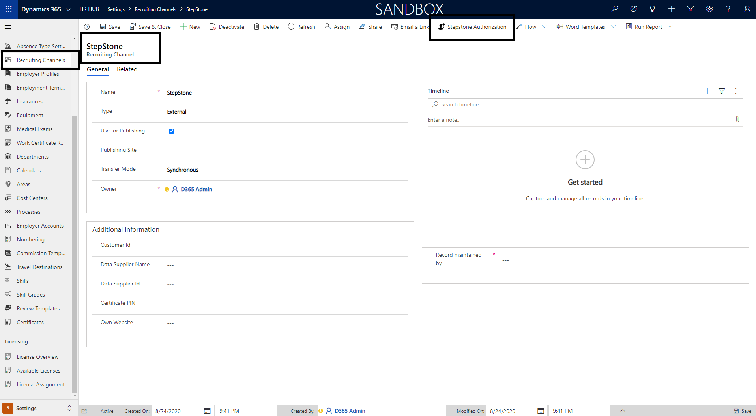
- A dialog will open when user clicks on “Stepstone Authorization” Button, User must enter all information mention in below dialog screenshot in order to Integrate/Publish Vacancy in Stepstone. The dialog is available in multiple supported languages like English, German etc.
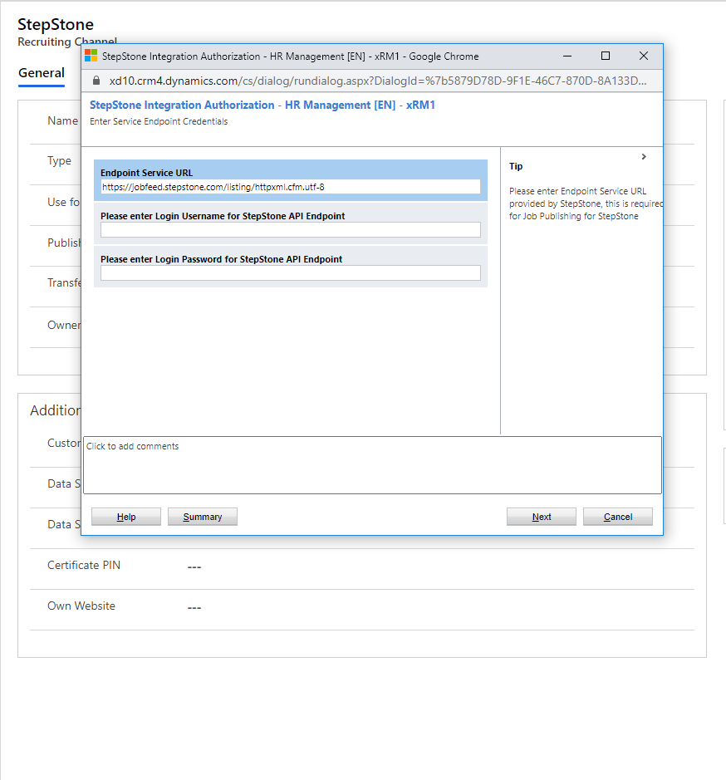
Endpoint Service URL: this is the API URL use to publish vacancy in stepstone system.
Username: To access stepstone API to publish vacancy, StepStone will provide this username at the time when customer make a contract with StepStone for vacancy publishing.
Password: To access stepstone API to publish vacancy, StepStone will provide this password at the time when customers make a contract with StepStone for vacancy publish.
On Next page user must enter organizational/employer information.
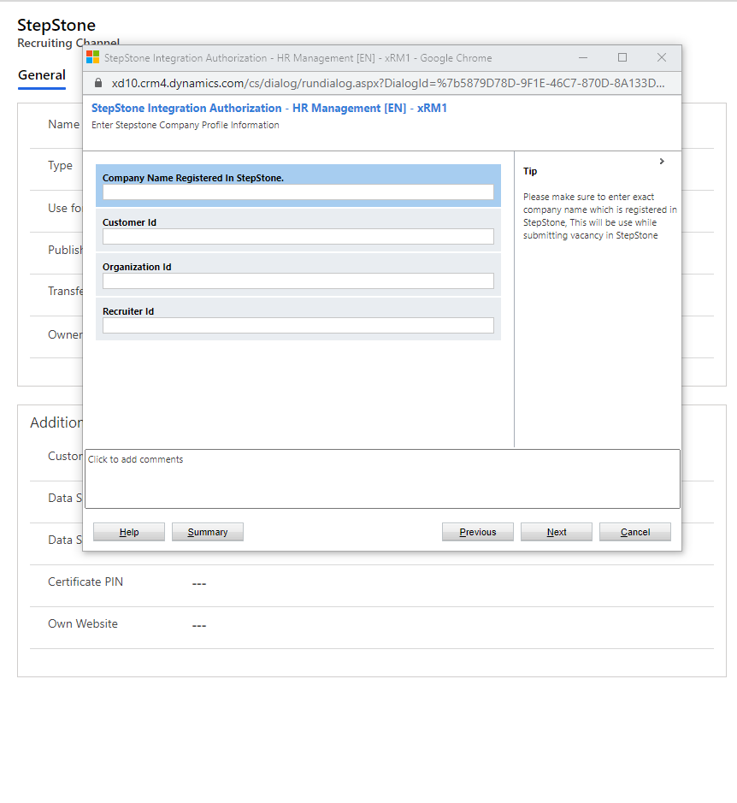
Company Name: Customer “Company Name” which is registered in StepStone.
Customer ID: Provided by StepStone.
Organization ID: Provided by StepStone.
Recruiter ID: Provided by StepStone.

Please connect with Stepstone Account Manager or a person which is taking care of your contract with StepStone to get all above information. Once an Employer make a contract with StepStone to publish a vacancy, StepStone setup an integration from their side as well for this Employer this include Recruiter Account as well, so a recruiter can access published Vacancy directly in StepStone Recruiting Portal.
After Finishing up with the dialog, system will create 3 records.
- xRM1IntegrationSettings Entity record for “StepstonePublishing”. This record contains API access information to publish vacancy in StepStone, please do not delete or create a duplicate record similar like this or deactivate this record, as this will affect Stepstone Vacancy Publishing Integration.
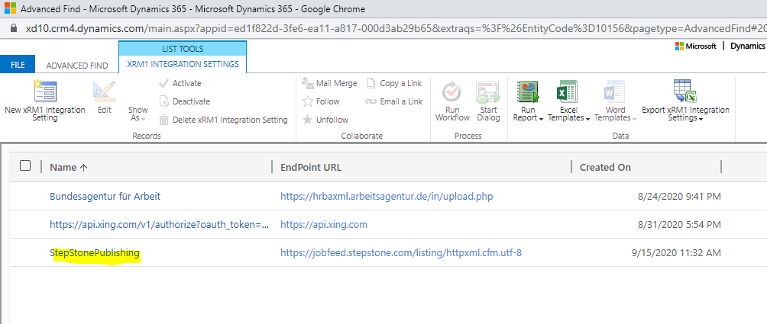
- xRM1IntegrationMapping Entity record for “StepstonePublishing”. This record contains all fields mapping information between HR for Dynamics Vacancy to Stepstone Vacancy. please do not delete or create a duplicate record similar like this or deactivate this record, as this will affect Stepstone Vacancy Publishing Integration.
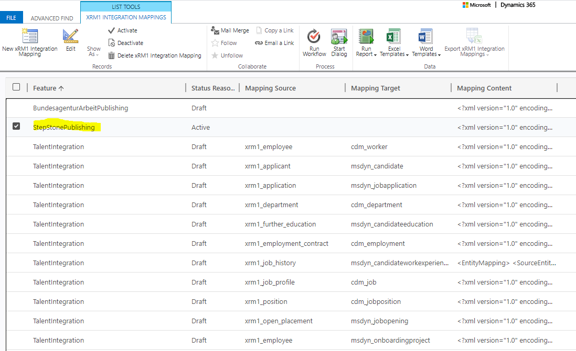

- Employer Profile Entity record for the employer (Customer) information provided by stepstone. This record relates to StepStone recruiting Channel. For Example: Hubdrive GmbH below.
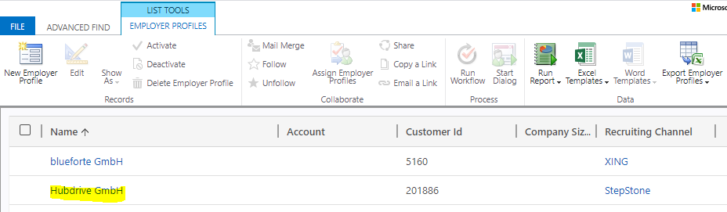

Summary:
A dialog can be used, which can be found in the Recruiting Channel, to set the authentication. So, the following records get created:
- xRM1 Integration Mapping: “StepStonePublishing” with Status Reason “Active”
- xRM1 Integration Setting: “StepStonePublishing”
- Employer Profile: with respective values from Employer Profile from StepStone

Vacancy Publishing in Stepstone

As these above records are created, the HR Manager can start to publish the Vacancies. The functionality is analog to other integrated job portals. To publish a Vacancy the Vacancy must be validated for StepStone. By choosing “validate for StepStone” the necessary fields become mandatory. When all mandatory fields are filled, the Vacancy can be published in the “Publishing” tab. The vacancy expiration date, the contract end date as well as the vacancy URL are filled automatically by getting a response for successful publishing from StepStone.
Please Note: To publish an update, you must start the publishing again. And please keep in mind, that changes made on the StepStone website are not updated to the system. For example, if you manually deactivate the vacancy in StepStone, this information will not be transferred to DHRM.
The deactivation of the publishing is automated in the following cases:
- the Vacancy is in the last stage of the Business Process Flow “Post-Processing” and “All positions filled” is marked with yes
- the Vacancy is deactivated in DHRM, independent from the status reason
In these cases, an offline request is sent to StepStone so that the vacancy will no longer be visible in StepStone. You can see if the vacancy is published in the field “Publishing Status” beneath the StepStone tab. This field is updated automatically every time an online or offline request is sent to StepStone. Likewise, the field is set to offline after the expiry date is reached and update requests will no longer be sent.
Please Note: The possibility “Stop” in publishing can only be used to stop the publishing for pending requests. It will not send an offline request.
When you extend the expiry of the vacancy publishing – which can be done in direct contact to StepStone – the expiry date gets updated after the next update request is sent to StepStone. Therefore, mark the field “Expiry extended” with yes. After publishing once again an update request is sent – even if the expiry is already exceeded – and from the response the expiry date will be updated. Simultaneously the field value is updated to “No”.

Following are the steps to publish vacancy in stepstone.
- Open vacancy which you want to publish in StepStone.
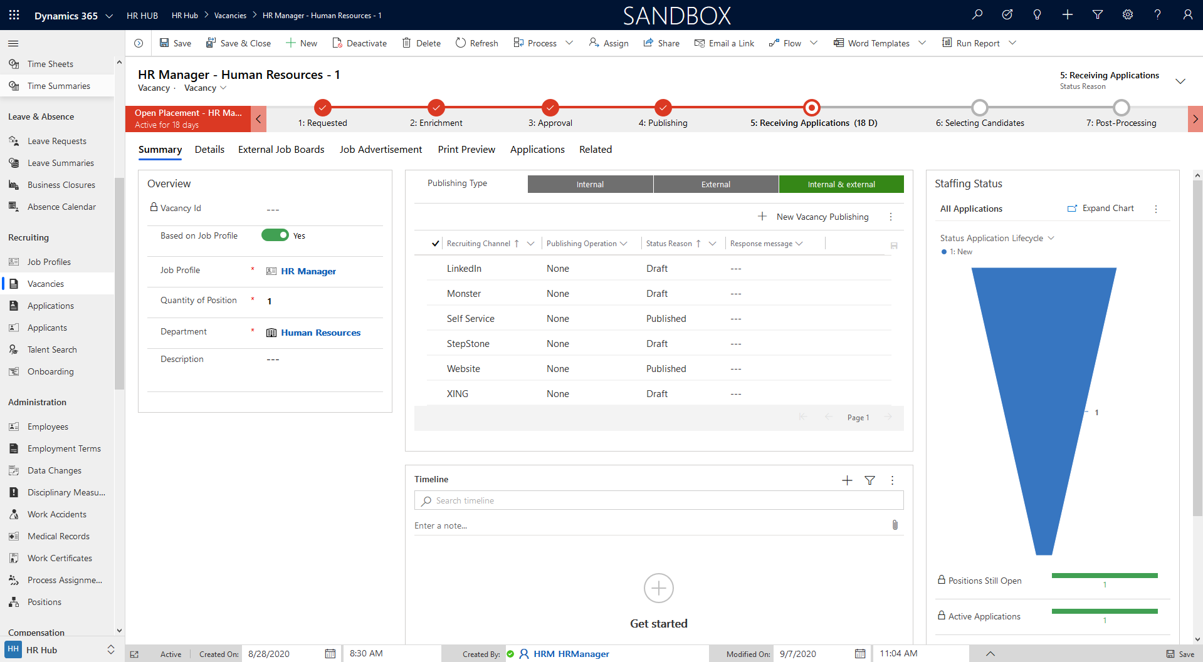
- Go to Tab “External Job Boards” and select “StepStone” in “Validate For” Optionset. Fill all required information which is available in Stepstone (Stepstone, Job Categorization and Display Information and Contract Details sections).
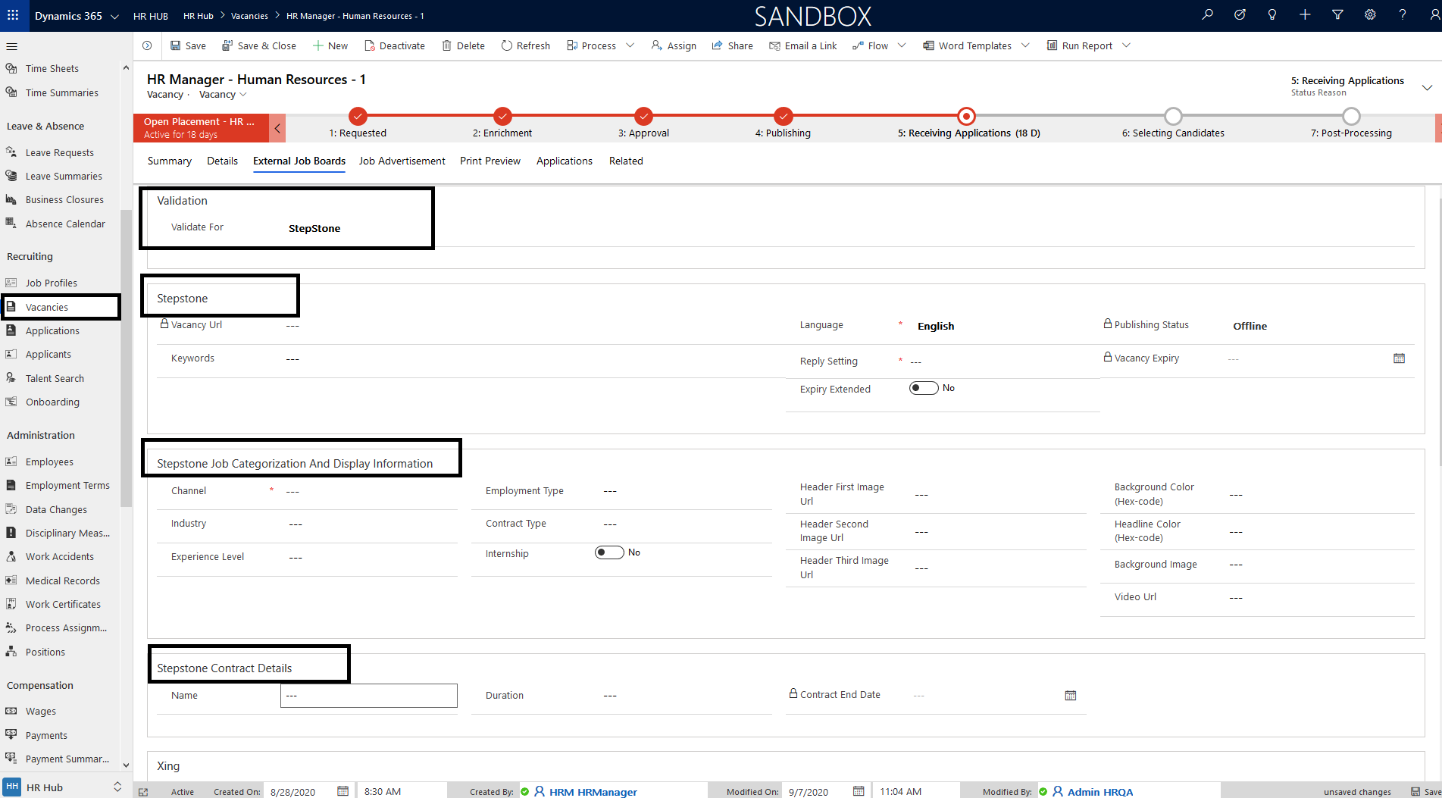
- StepStone also has feature to show “Recruiter Card” in stepstone vacancy portal, user has to fill recruiting contact details if they want to show recruiter information.
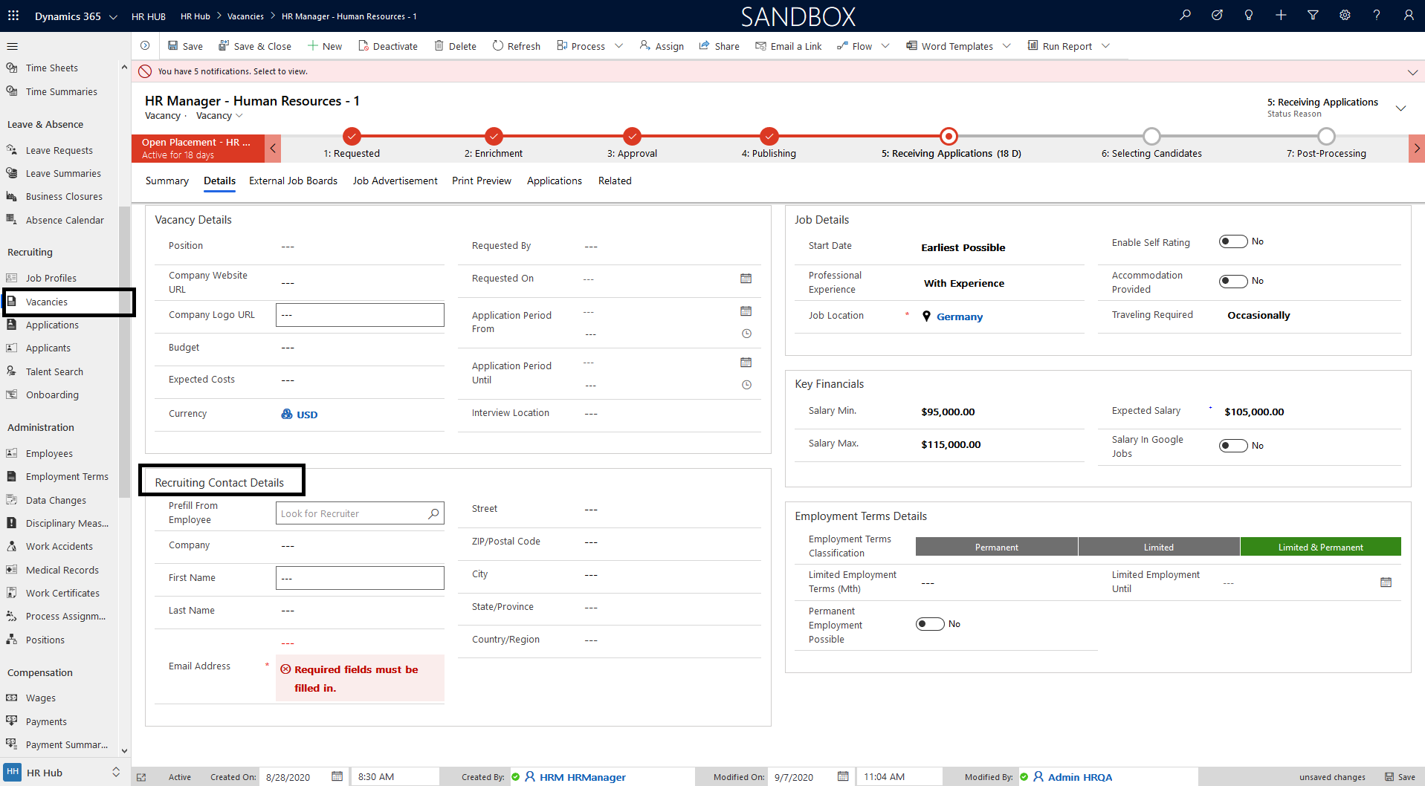

- After entering all required information, go to “Summary” tab and click on StepStone record and select “Start” in the publishing operation column. And then click “save” button in the top left corner of the view.
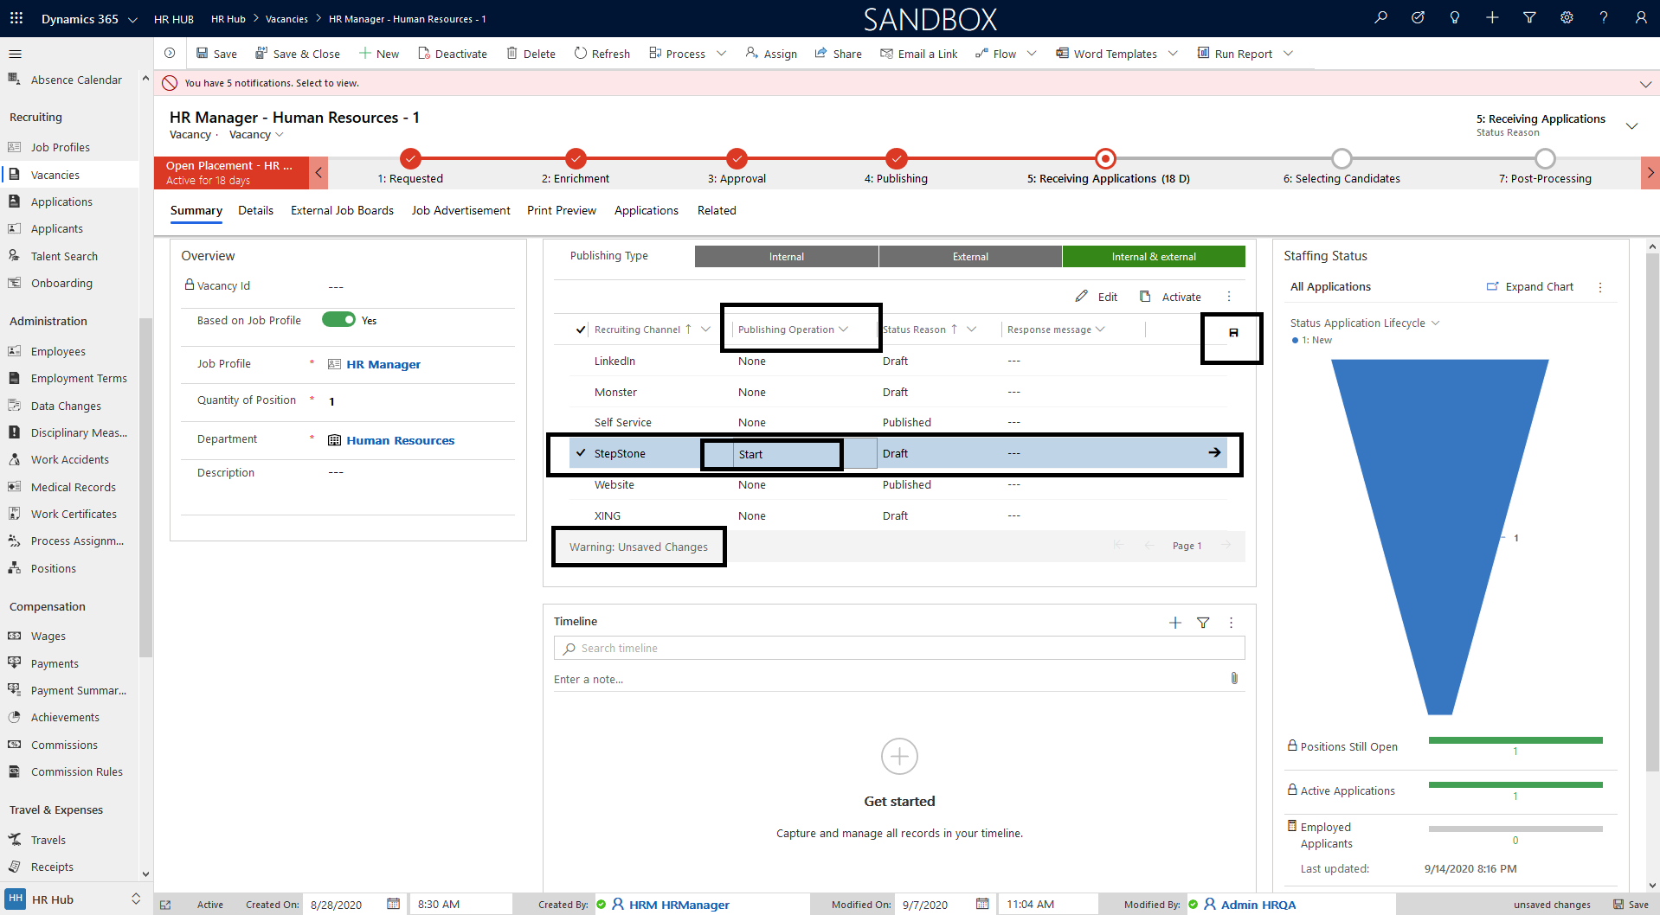
- After saving the record, user will see the message “Vacancy published successfully”. This message shows the vacancy is successfully published in StepStone. To cross check go to Stepstone Recruiting Portal using Recruiter account.

