Broadbean Integration Setup and Vacancy Publishing

visit www.dynamics-hr-management.com

Setting Up Broadbean Integration:

Before starting with the publishing to Broadbean, the integration must be activated by Broadbean. In the DHRM-Solution the authentication must be set, whereby the credentials are given by Broadbean.
Following are the steps to setup Broadbean integration.
- Open HR Hub App, go to settings and then go to Recruiting Channels.
- Open Broadbean Recruiting Channel Record and Click on button “Authenticate Broadbean”.
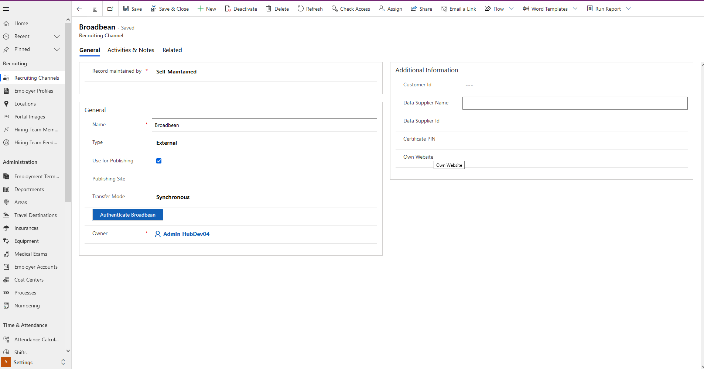
- A dialog will open when user clicks on “Authenticate Broadbean” Button, User must enter all information mention in below dialog screenshot in order to Integrate/Publish Vacancy in Broadbean. The dialog is available in multiple supported languages like English, German etc.
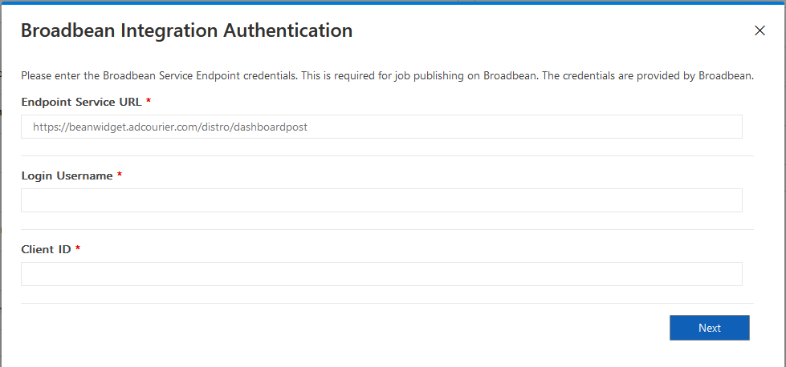
Endpoint Service URL: this is the API URL use to publish vacancy in Broadbean system.
Username: To access Broadbean API to publish vacancy, Broadbean will provide this username at the time when customer make a contract with Broadbean for vacancy publishing.
Client Id: To access Broadbean API to publish vacancy, Broadbean will provide this client id at the time when customers make a contract with Broadbean for vacancy publish.
On Next page user must enter API Key/Secret Key.
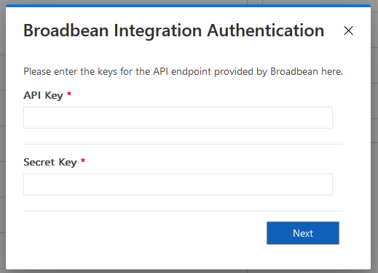
API Key: Provided by Broadbean
Secret Key: Provided by Broadbean

After finishing up with the dialog, system will create 2 records.
- xRM1IntegrationSettings Entity record for “BroadbeanPublishing”. This record contains API access information to publish vacancy in Broadbean, please do not delete or create a duplicate record similar like this or deactivate this record, as this will affect Broadbean Vacancy Publishing Integration.
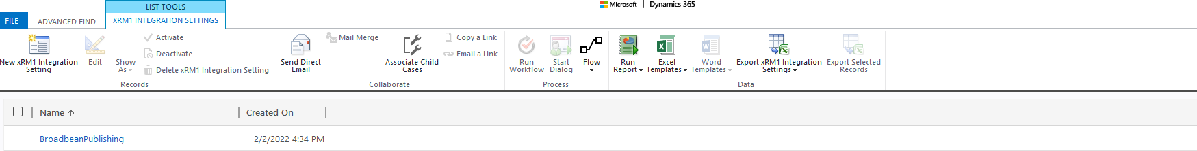

- xRM1IntegrationMapping Entity record for “BroadbeanPublishing”. This record contains all fields mapping information between HR for Dynamics Vacancy to Broadbean Vacancy. please do not delete or create a duplicate record similar like this or deactivate this record, as this will affect Broadbean Vacancy Publishing Integration.
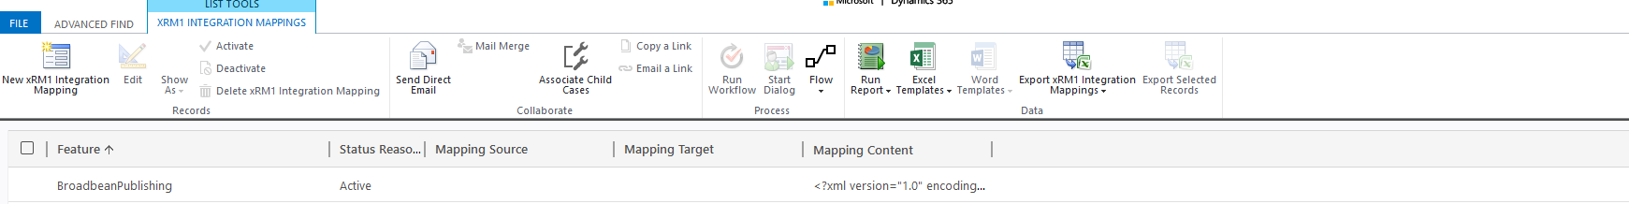
Broadbean Integration Mapping
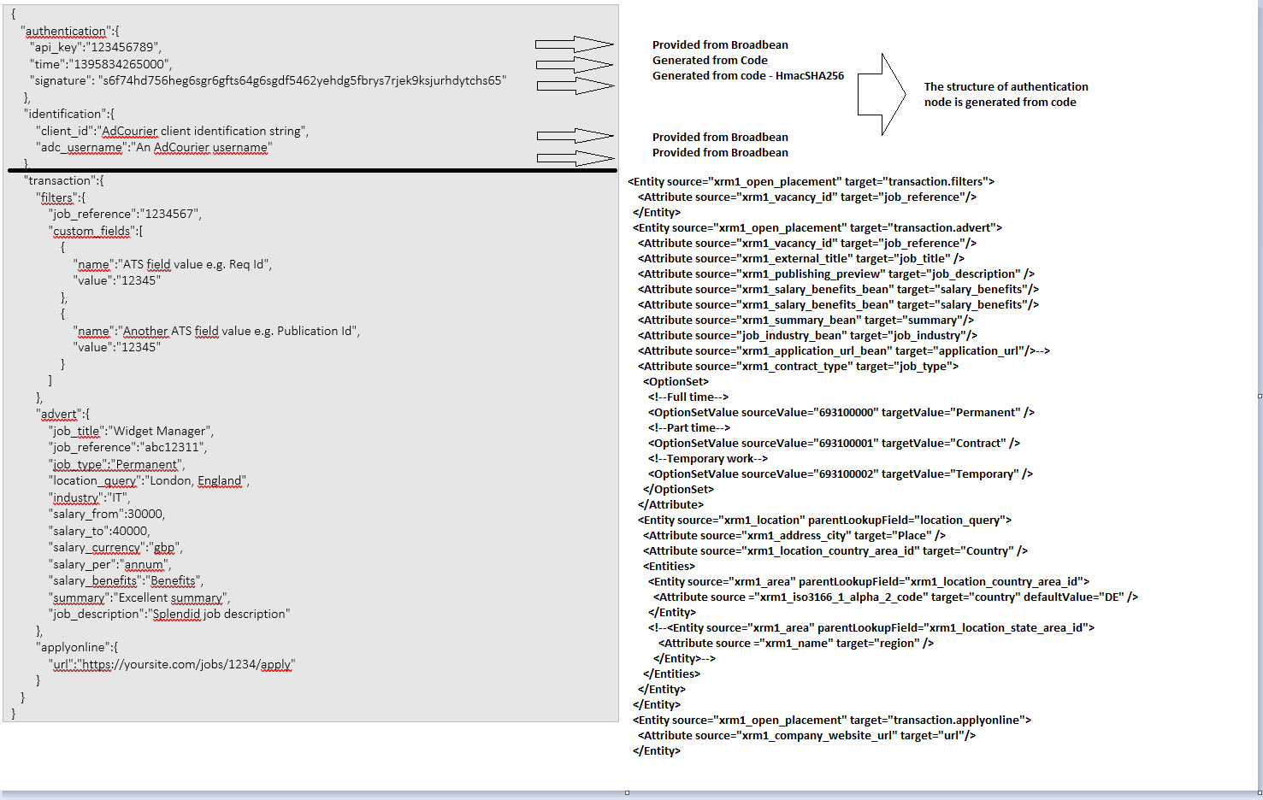

Summary:
A dialog can be used, which can be found in the Recruiting Channel, to set the authentication. So, the following records get created:
- xRM1 Integration Mapping: “BroadbeanPublishing” with Status Reason “Active”
- xRM1 Integration Setting: “BroadbeanPublishing”

Numbering for Vacancy
The Vacancy can be published in Broadbean if the Vacancy Id is generated before publishing, the record for Vacancy Id in “Numbering” should be created
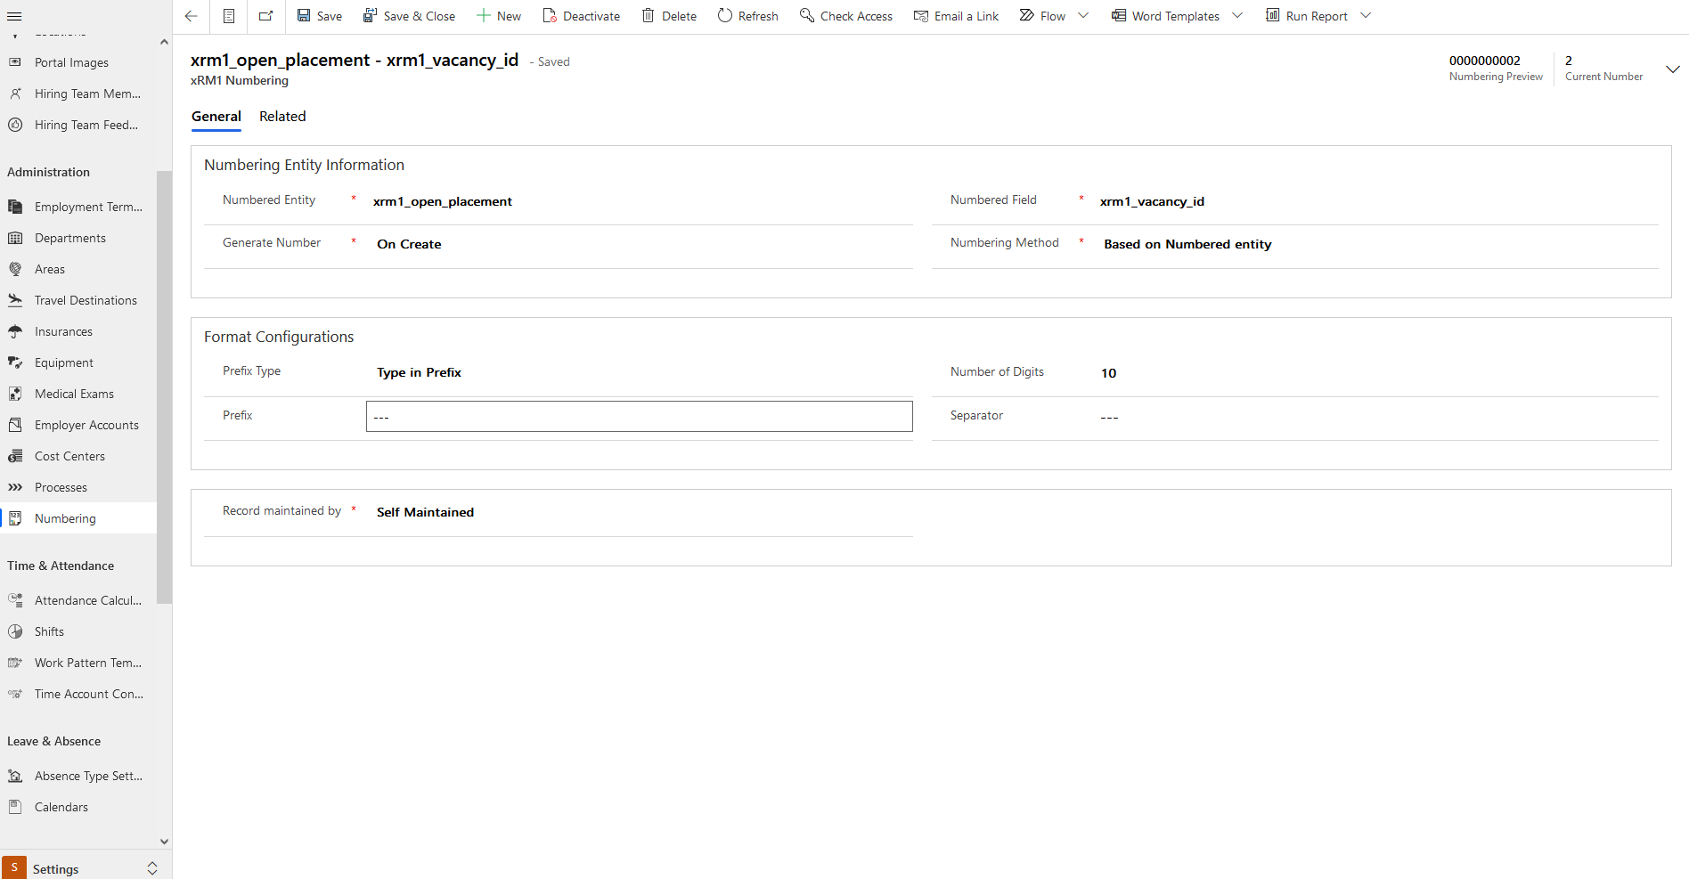

Job Profile
Before starting with the publishing to Broadbean Job Profile should be created, the fields which are used for Broadbean publishing inside “Advertisement Template” are: “{xrm1_stepstone_introduction_title},{xrm1_header},{xrm1_stepstone_task_title},{xrm1_job_definition},{xrm1_stepstone_profile_title},{xrm1_qualifications},{xrm1_stepstone_offer_title},{xrm1_stepstone_offer},{xrm1_stepstone_contactinfo_title},{xrm1_footer}”

Vacancy Publishing in Broadbean

As these above records are created, the HR Manager can start to publish the Vacancies. The functionality is analogue to other integrated job portals. To publish a Vacancy the Vacancy must be validated for Broadbean. By choosing “validate for Broadbean” the necessary fields become mandatory. When all mandatory fields are filled, the Vacancy can be published in the “Publishing” tab. The vacancy expiration date, the contract end date as well as the vacancy URL are filled automatically by getting a response for successful publishing from Broadbean.
Following are the steps to publish vacancy in Broadbean.
- Open vacancy which you want to publish in Broadbean.
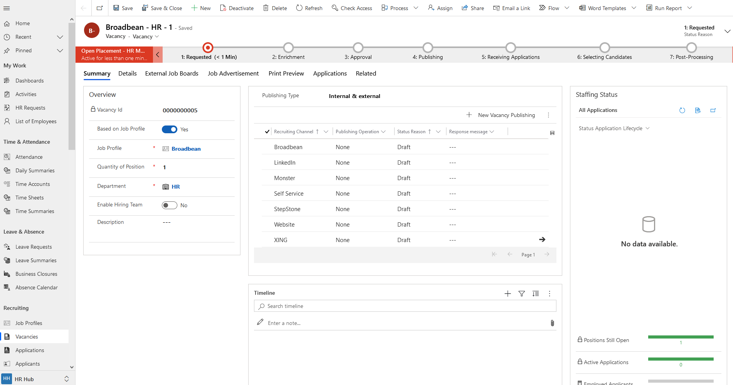

- Go to Tab “External Job Boards” and select “Broadbean” in “Validate For” Optionset. Fill all required information which is available in Broadbean (Broadbean: Vacancy Details).
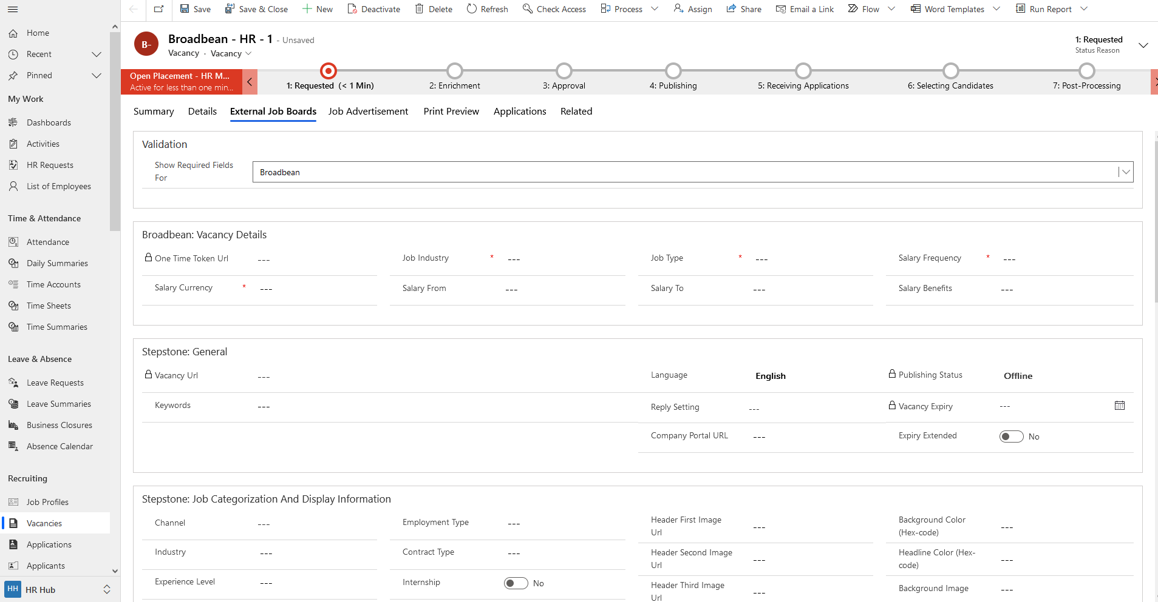

- Mandatory field is also “Location” and “Company Website URL” which is located inside Tab “Details”

- After entering all required information, go to “Summary” tab and click on Broadbean record and select “Start” in the publishing operation column. And then click “save” button in the top left corner of the view.

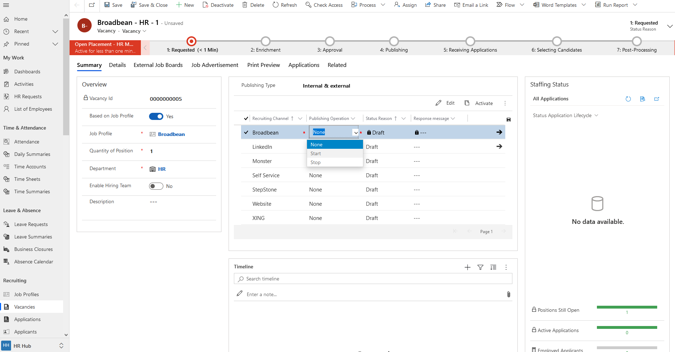

- After saving the record, page will be reloaded, user will see the message “Vacancy published successfully” and Broadbean Tab will be visible to select Job Boards and publish vacancy in selected Job Boards.
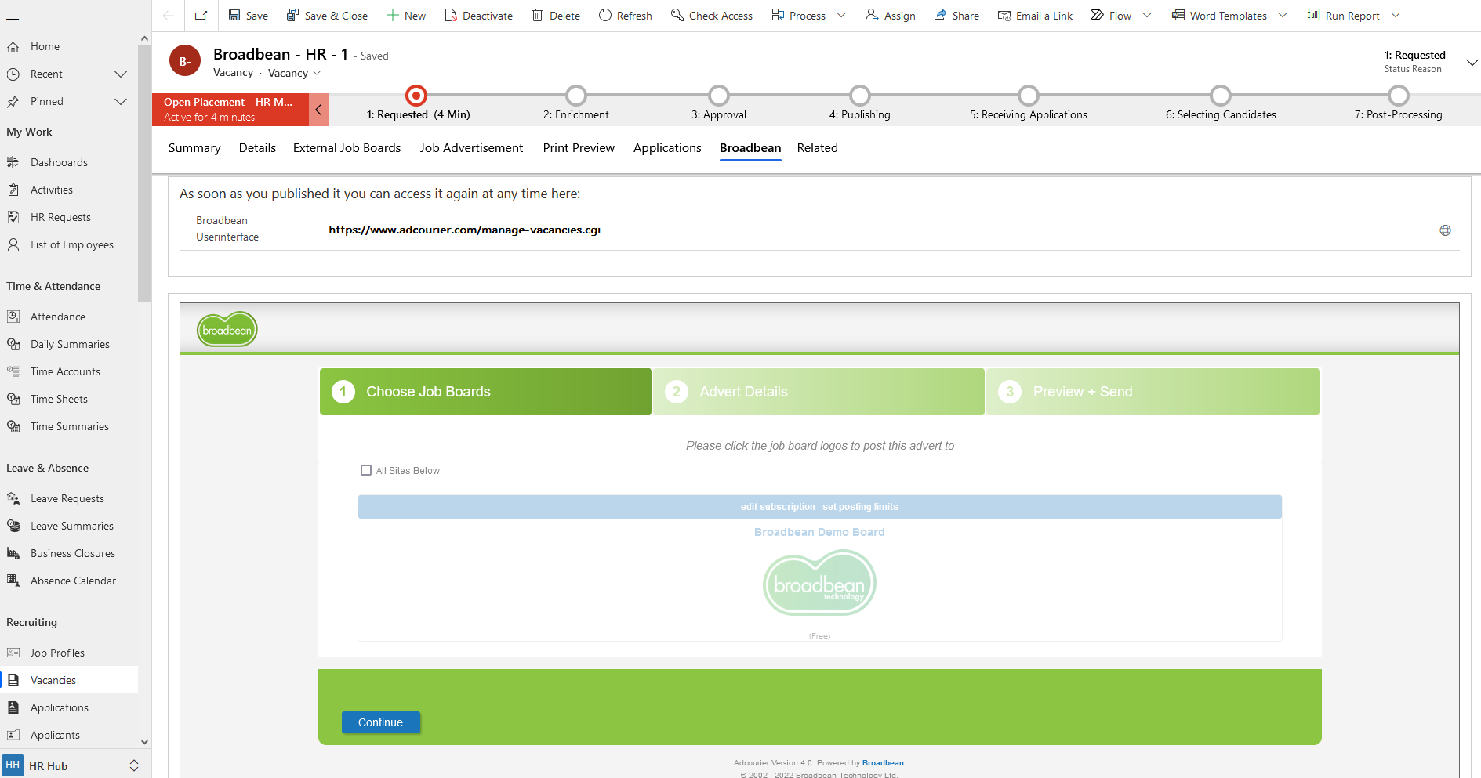

- When three steps are finished the page will be redirected to the list of published vacancies.

